CASE STUDY 5: AUTOMATED BANKING TRANSACTION AND WALLET AUDIT SYSTEM
1 PROBLEM STATEMENT
Design and implement a robust financial transaction processing module that evaluates sequential account operations (deposits, withdrawals, and transfers), enforces strict operational constraints (maximum per-withdrawal limits, daily aggregate withdrawal caps, and sufficient balance checks), validates data input types, and generates a comprehensive transaction reconciliation audit summary.
2 OBJECTIVES
- Initialize banking state with a predefined starting balance and operational limits.
- Validate transaction types and ensure transaction amounts are positive numeric values.
- Enforce financial rules: per-withdrawal caps, daily withdrawal limits, and non-negative balance checks for withdrawals.
- Categorize and record successful versus rejected transactions along with specific failure reasons.
- Compute total deposits, total withdrawals, and final account balances for executive audit reporting.
3 KEY ASSUMPTIONS
Initial balances and withdrawal thresholds are fixed configuration parameters. Invalid transaction types or non-numeric/negative amounts are automatically rejected without disrupting the processing queue.
4 ALGORITHM
- Initialize balance, withdrawn_today, accepted list, and rejected list.
- Iterate through sequential transaction records.
- Validate that transaction amounts are numeric and greater than zero; otherwise, reject with appropriate reasons.
- For deposits, add the amount to the balance.
- For withdrawals, verify against MAX_PER_WITHDRAWAL, DAILY_WITHDRAWAL_LIMIT (including accumulated daily withdrawals), and current balance. If valid, update balance and daily withdrawal sum; otherwise, reject with failure reason.
- For unknown transaction types, reject with an error message.
- Output real-time processing logs and generate a final summary report of accepted and rejected items.
5 FLOWCHART REPRESENTATION
Plaintext
[Start] -> [Read Transactions & Limits] -> [Check Numeric & Positive Amount?]
-> [Kind == Deposit? Yes: Add to Balance]
-> [Kind == Withdraw? Check Per-Withdrawal, Daily Limit, & Balance]
-> [Valid? Yes: Update Balance & Daily Total | No: Reject with Reason]
-> [End of List? Yes: Print Financial Summary | No: Process Next Transaction] -> [End]
6 PSEUDOCODE
Plaintext
FUNCTION process_transaction(kind, amount):
IF amount is not numeric: RETURN False, "Amount is not a number"
IF amount <= 0: RETURN False, "Amount must be greater than zero"
IF kind == "deposit":
balance += amount
RETURN True, "OK"
ELSE IF kind == "withdraw":
IF amount > MAX_PER_WITHDRAWAL: RETURN False, "Exceeds per-withdrawal limit"
IF withdrawn_today + amount > DAILY_WITHDRAWAL_LIMIT: RETURN False, "Exceeds daily limit"
IF amount > balance: RETURN False, "Insufficient funds"
balance -= amount
withdrawn_today += amount
RETURN True, "OK"
ELSE:
RETURN False, "Unknown transaction type"
8 TEST CASES
Transaction Item | Input Details | Expected Outcome | Failure Reason / Status
TC-01: Valid Deposit | ("deposit", 200) | Accepted | Balance updated successfully
TC-02: Negative Amount | ("deposit", -50) | Rejected | Amount must be greater than zero
TC-03: Exceeds Per-Withdrawal | ("withdraw", 600) | Rejected | Exceeds per-withdrawal limit of 500
TC-04: Non-Numeric Amount | ("deposit", "abc") | Rejected | Amount is not a number
9 OUTPUT SCREENSHOTS
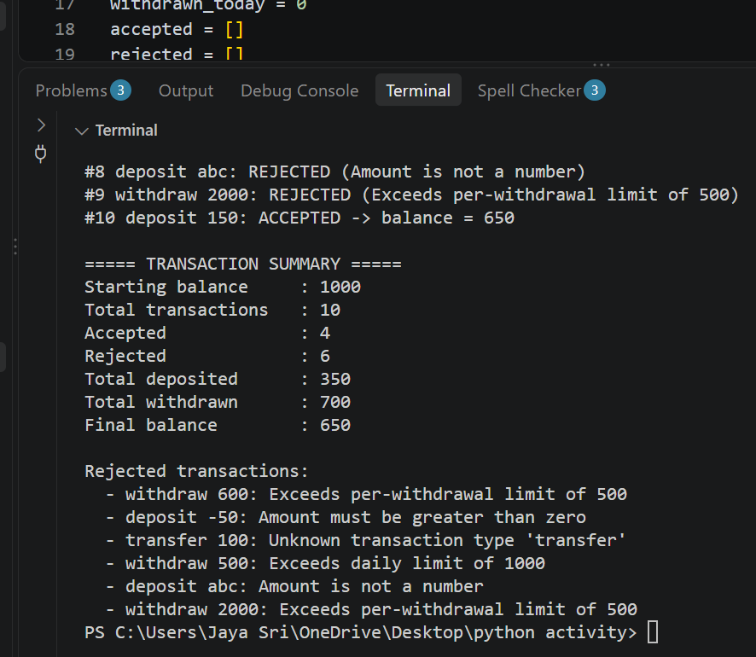
10 CONCLUSION
The banking transaction auditing module successfully enforces safety constraints, handles invalid data types robustly, and provides transparent reconciliation summaries for financial monitoring.

